With 2016 the Tesla Model S got an update
Tesla model S has changed the front fascia and now has a similar design as the Model X, adding adaptive LED headlights.

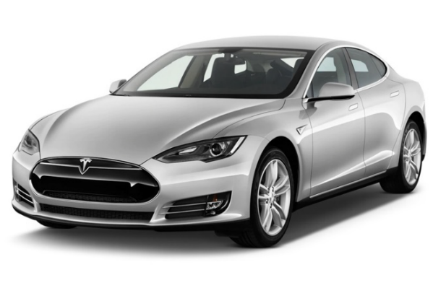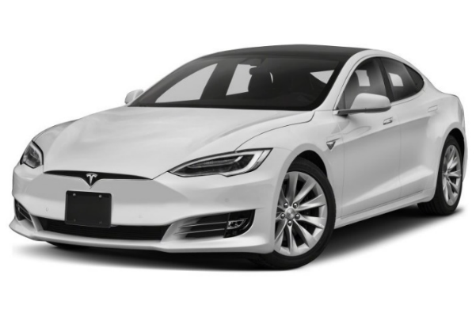
Tesla Model S before face-lifting Tesla Model S after facelift HID LED

What's the LED - HID emulator for ?
LED-HID emulator allows you to adapt new LED headlight to older Tesla Model S before facelift.
The emulator converts analogue inputs to digital and transmits to the LED headlights.
With that EMULATOR you can connect LED (New face headlights) to old Tesla Model S with HID lights.
Applies to Tesla model S with old HID lamps only – Tesla Model S 2012 - June 2016

How to connect LED - HID emulator

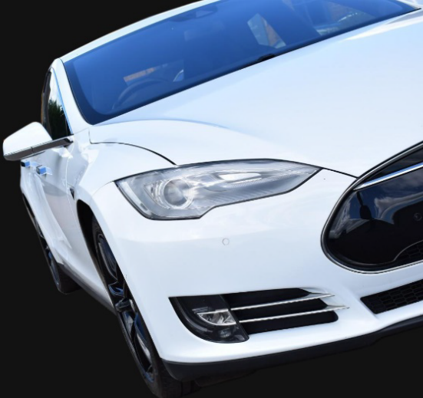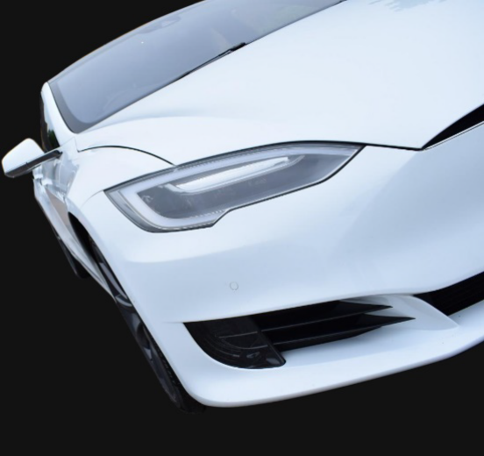

Before you start the new LED lamps has to be attached

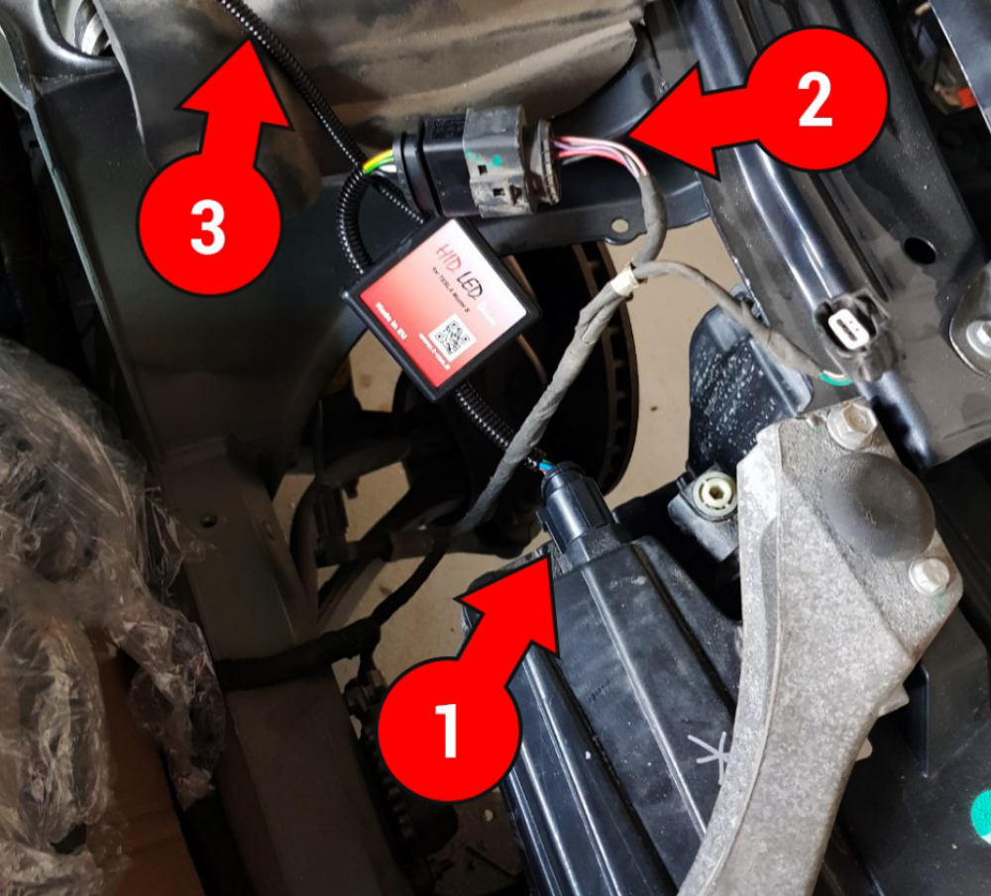

connect all connectors (description below)

1) plug it to the LED lamp
2) plug it to HID-LED emulator
3) connect the emulator power supply to the battery (positive and negative)
- RED +12v positive terminal
- BLACK GND negative terminal
4) Check all connections again.
5) Done !

we strongly recommend using a 15A fuse for protection

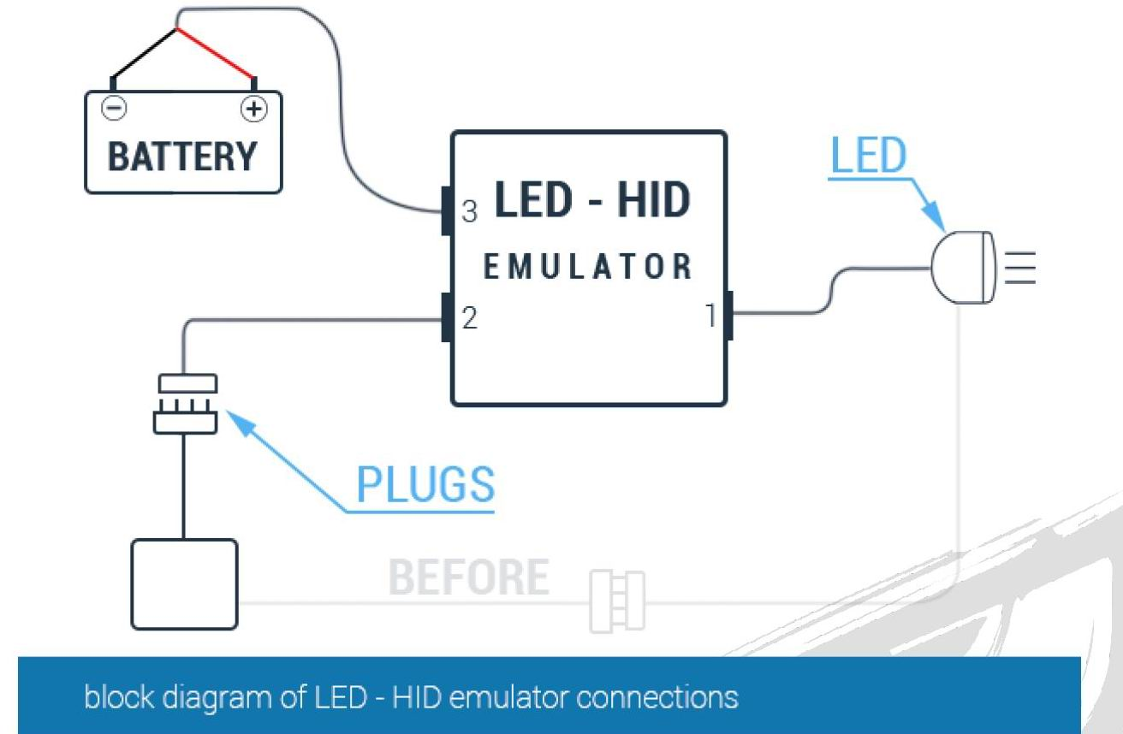

Now you can enjoy of new fully working LED headlights
The emulator is working like analog to digital converter (A/D)

